1. Rescue
运行截图：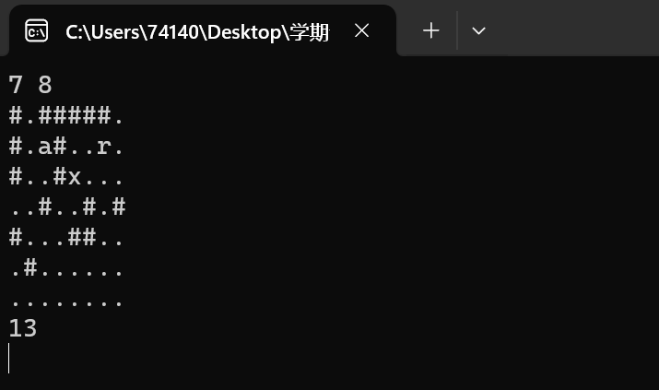
程序代码：#include <iostream>
#include <queue>
#include <vector>

using namespace std;

struct Point {
int x, y, steps;
Point(int x, int y, int steps) : x(x), y(y), steps(steps) {}
};

int bfs(vector<vector<char>>& prison, int startX, int startY) {
int N = prison.size();
int M = prison[0].size();

vector<vector<bool>> visited(N, vector<bool>(M, false));
queue<Point> q;
q.push(Point(startX, startY, 0));

while (!q.empty()) {
Point current = q.front();
q.pop();

int x = current.x;
int y = current.y;
int steps = current.steps;

if (prison[x][y] == 'a') {
return steps;
}

// Try moving in four directions
int dx[] = { 0, 0, 1, -1 };
int dy[] = { 1, -1, 0, 0 };

for (int i = 0; i < 4; ++i) {
int nx = x + dx[i];
int ny = y + dy[i];

if (nx >= 0 && nx < N && ny >= 0 && ny < M && prison[nx][ny] != '#' && !visited[nx][ny]) {
visited[nx][ny] = true;
q.push(Point(nx, ny, steps + 1));
}
}
}

return -1; // No path found
}

int main() {
int N, M;
while (cin >> N >> M) {
vector<vector<char>> prison(N, vector<char>(M));
int startX, startY;

for (int i = 0; i < N; ++i) {
for (int j = 0; j < M; ++j) {
cin >> prison[i][j];
if (prison[i][j] == 'r') {
startX = i;
startY = j;
}
}
}

int result = bfs(prison, startX, startY)+1;

if (result == -1) {
cout << "Poor ANGEL has to stay in the prison all his life." << endl;
}
else {
cout << result << endl;
}
}

return 0;
}

2. 胜利大逃亡
运行截图：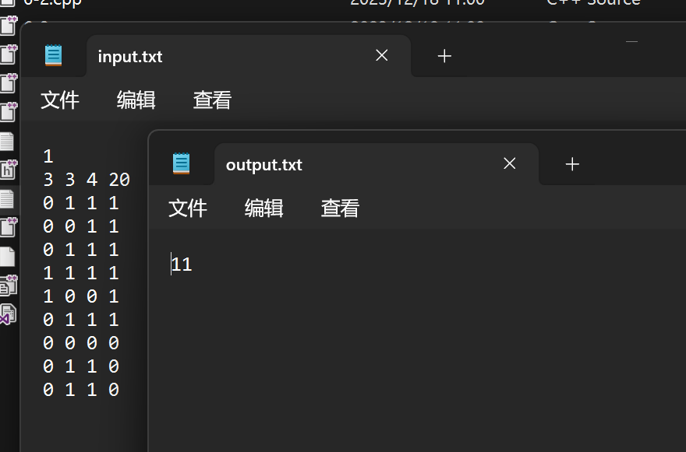
程序代码：#define _CRT_SECURE_NO_WARNINGS
#include <cstdio>
#include <queue>

using namespace std;

struct Point {
int x, y, z, time;
Point(int x, int y, int z, int time) : x(x), y(y), z(z), time(time) {}
};

int main() {
// 将标准输入重定向到文件
freopen("input.txt", "r", stdin);
// 将标准输出重定向到文件
freopen("output.txt", "w", stdout);

int K;
scanf("%d", &K);

while (K--) {
int A, B, C, T;
scanf("%d%d%d%d", &A, &B, &C, &T);

int castle[50][50][50];
for (int i = 0; i < A; ++i) {
for (int j = 0; j < B; ++j) {
for (int k = 0; k < C; ++k) {
scanf("%d", &castle[i][j][k]);
}
}
}

queue<Point> q;
int visited[50][50][50] = { 0 };

q.push(Point(0, 0, 0, 0));
visited[0][0][0] = 1;

int dx[] = { 1, -1, 0, 0, 0, 0 };
int dy[] = { 0, 0, 1, -1, 0, 0 };
int dz[] = { 0, 0, 0, 0, 1, -1 };

while (!q.empty()) {
Point current = q.front();
q.pop();

int x = current.x;
int y = current.y;
int z = current.z;
int time = current.time;

if (x == A - 1 && y == B - 1 && z == C - 1) {
if (time <= T) {
printf("%d\n", time);
}
else {
printf("-1\n");
}
break;
}

for (int i = 0; i < 6; ++i) {
int nx = x + dx[i];
int ny = y + dy[i];
int nz = z + dz[i];

if (nx >= 0 && nx < A && ny >= 0 && ny < B && nz >= 0 && nz < C &&
castle[nx][ny][nz] == 0 && !visited[nx][ny][nz]) {
visited[nx][ny][nz] = 1;
q.push(Point(nx, ny, nz, time + 1));
}
}
}

// Add a newline to ensure correct output flushing
printf("\n");
}

return 0;
}

3. Oil Deposits
运行截图：
程序代码：#include <iostream>
#include <fstream>
#include <vector>

using namespace std;

void explore(vector<vector<char>>& grid, int i, int j) {
int rows = grid.size();
int cols = grid[0].size();

if (i < 0 || i >= rows || j < 0 || j >= cols || grid[i][j] == '*') {
return;
}

grid[i][j] = '*'; // Mark the current plot as visited

// Explore all eight possible directions
for (int dx = -1; dx <= 1; ++dx) {
for (int dy = -1; dy <= 1; ++dy) {
explore(grid, i + dx, j + dy);
}
}
}

int countOilDeposits(vector<vector<char>>& grid) {
int rows = grid.size();
int cols = grid[0].size();
int count = 0;

for (int i = 0; i < rows; ++i) {
for (int j = 0; j < cols; ++j) {
if (grid[i][j] == '@') {
explore(grid, i, j);
count++;
}
}
}

return count;
}

int main() {
ifstream infile("input.txt");
ofstream outfile("output.txt");

int m, n;

while (true) {
infile >> m >> n;

if (m == 0) {
break;
}

vector<vector<char>> grid(m, vector<char>(n));

for (int i = 0; i < m; ++i) {
for (int j = 0; j < n; ++j) {
infile >> grid[i][j];
}
}

int result = countOilDeposits(grid);
outfile << result << endl;
}

infile.close();
outfile.close();

return 0;
}

4. I NEED A OFFER!

运行截图：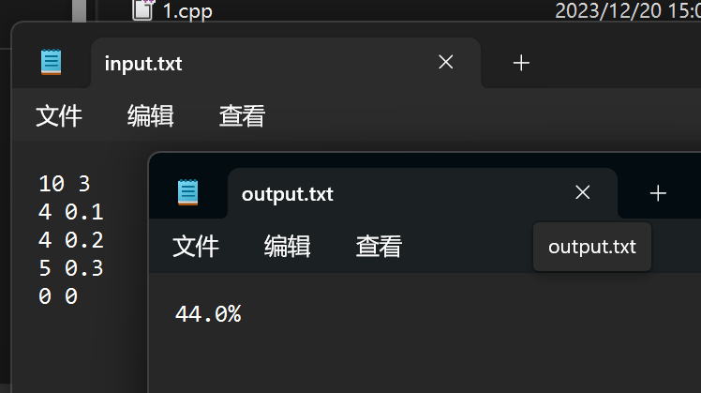
程序代码：#include <iostream>
#include <fstream>
#include <algorithm>
#include <cmath>
#include <cstring>
#include <string>
#include <vector>
#include <set>
#include <stack>
#include <list>
#include <map>

#define P(x) x > 0 ? x : 0
#define INF 0x3f3f3f3f

using namespace std;
typedef long long ll;
const int maxn = 1e4 + 5;
const int maxm = 1e4 + 5;

int n, m;
double dp[maxn];
double ans;
struct node
{
int a;
double b;
node(int aa = 0, double bb = 0) : a(aa), b(bb) {}
friend bool operator<(node n1, node n2)
{
return n1.a < n2.a;
}
} item[maxm];

void init()
{
for (int i = 0; i < maxn; i++)
{
dp[i] = 1;
}
ans = 1;
}

int main()
{
ifstream infile("input.txt");
ofstream outfile("output.txt");

while (true)
{
infile >> n >> m;

if (n == 0 && m == 0)
{
break;
}

init();

for (int i = 1; i <= m; i++)
{
infile >> item[i].a >> item[i].b;
item[i].b = 1 - item[i].b; //我们让item[i].b存不会被录取的概率
}

if (n == 0)
{
for (int i = 1; i <= m; i++)
{
if (item[i].a == 0)
ans *= item[i].b;
}
outfile << fixed;
outfile.precision(1);
outfile << (1 - ans) * 100 << "%" << endl;
continue;
}

for (int i = 1; i <= m; i++)
{
for (int j = n; j >= item[i].a; j--)
{
dp[j] = min(dp[j - item[i].a] * item[i].b, dp[j]);
}
}

for (int i = 1; i <= n; i++)
ans = min(ans, dp[i]);

outfile << fixed;
outfile.precision(1);
outfile << (1 - ans) * 100 << "%" << endl;
}

infile.close();
outfile.close();

return 0;
}

5. 非常可乐

运行结果：
程序代码：#include <iostream>
#include <fstream>
#include <queue>
#include <cstring>

using namespace std;

struct node
{
int a;
int b;
int c;
int step;
};

int s, n, m;
int flag;
int ans;
int vis[101][101][101];

void bfs()
{
queue<node> q;
node p;
p.a = s;
p.b = 0;
p.c = 0;
p.step = 0;
vis[s][0][0] = 1;
q.push(p);
node t;
while (!q.empty())
{
node k = q.front();
q.pop();
if ((k.a + k.b == s && k.a == k.b) || (k.a + k.c == s && k.a == k.c) || (k.b + k.c == s && k.b == k.c)) //要平分才行
{
flag = 1;
ans = k.step; //输出倒的次数
return;
}
for (int i = 0; i < 6; i++)
{
if (i == 0) //a->b
{
if (k.a + k.b > n)
{
t.a = k.a + k.b - n;
t.b = n;
t.c = k.c;
}
else
{
t.b = k.a + k.b;
t.a = 0;
t.c = k.c;
}
}
else if (i == 1) //a->c
{
if (k.a + k.c > m)
{
t.a = k.a + k.c - m;
t.c = m;
t.b = k.b;
}
else
{
t.c = k.a + k.c;
t.a = 0;
t.b = k.b;
}
}
else if (i == 2) //b->c
{
if (k.b + k.c > m)
{
t.b = k.b + k.c - m;
t.c = m;
t.a = k.a;
}
else
{
t.c = k.b + k.c;
t.b = 0;
t.a = k.a;
}
}
else if (i == 3) //b->a//这里不进行if-else是因为可乐桶绝不会溢出来，他的容量是最大的
{
t.a = k.a + k.b;
t.b = 0;
t.c = k.c;
}
else if (i == 4) //c->a
{
t.a = k.a + k.c;
t.c = 0;
t.b = k.b;
}
else if (i == 5) //c->b
{
if (k.b + k.c > n)
{
t.c = k.b + k.c - n;
t.b = n;
t.a = k.a;
}
else
{
t.b = k.b + k.c;
t.c = 0;
t.a = k.a;
}
}
if (vis[t.a][t.b][t.c] == 0) //基本BFS入队列操作
{
t.step = k.step + 1;
vis[t.a][t.b][t.c] = 1;
q.push(t);
}
}
}
}

int main()
{
ifstream infile("input.txt");
ofstream outfile("output.txt");

while (true)
{
infile >> s >> n >> m;

if ((s == 0 && n == 0 && m == 0))
{
break;
}

memset(vis, 0, sizeof(vis));
flag = 0;
ans = 0;

if (s % 2 == 1) //奇数绝对不可能平分，因为必须保证第三个杯子为空切没有小数出现
{
outfile << "NO" << endl;
break;

}
else
{
bfs();
if (flag)
{
outfile << ans << endl;
break;
}
else
{
outfile << "NO" << endl;
break;
}
}
}

infile.close();
outfile.close();

return 0;
}

